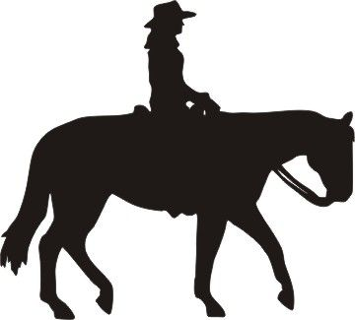
Holly Hill Farm Equestrian Team
Invites You To the
2017 Central-East Conference Show
On Sunday, October 8, 2017
In Avon Lake, OH

Date: Sunday, October 8, 2017

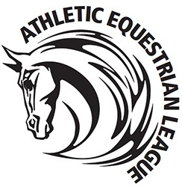
Judge: Kim Segedy- Hudson, OH
Steward: April Woodward, Huntsburg, OH

Practicum Phase: #2
Pattern: #1
Available at www.athleticequestrian.com

Schedule of Events
8:00 am: Schooling of Horses
8:45 am: Coaches meeting and Draw
9:15 am: Open Horsemanship and Patterns begins
Intermediate
Novice
Advanced Beginner Beginner
Minis

The Holly Hill Farm Equestrian Team AEL competition will run according to the rules and regulations of the AEL.
Entry Fee: $60/Rider payable to Holly Hill Farm Equestrian Team
Organizer: Lisa Byrom hollyhillfarm.lisa@yahoo.com 440-666-7158
Entry Deadline: Entries are due to Competition Organizer by Monday, October 2, 2017. Please email the completed entry form to the email address above. No changes in entries will be accepted after Thursday, October 5. Scratches received after 10/5 will still need to pay full dues. Please bring the completed entry form and payment to the competition.

We will have a concession stand open- Hamburgers, hot dogs, walking tacos, pulled pork sandwiches, snacks and drinks. NO DOGS PLEASE!!
Location: 31770 Krebs Road, Avon Lake, OH 44012

Holly Hill Farm Sunday, October 8, 2017 Team Name: ______ _ _ _ _ _ _ _ _ _ _ _ _ _ _ _ _ Coach: ___ _ _ _ _ _ _ _ _ _ _ _ _ _ _ _ _ _ _ _ _

Phone: ____ _ _ _ _ _ _ _ _ Email: _____ _ _ _ _ _ _ _
*Please list according to Division (all Open Riders, all Intermediate Riders…)

RIDER # | NAME | DIVISION | GRADE
This entry constitutes an agreement and affirmation that the Athlete/Parent making it, the Club, and each of its riders, coaches and trainers shall accept and abide by the rules of the AEL and of the Competition, that each rider is eligible as entered, that they will accept as final any rulings of the AEL with respect to their conduct and each entry agrees to defend and hold the AEL, its directors, officials, employees and all persons, stables or other entities providing facilities, horses or equipment for the Competition, harmless for any claim, action or suit, for injury, property damage or death sustained during participation in the show by the entity, his or her coach, trainer or visitors.

Coach Signature______ _ _ _ _ _ _ _ _ _ _ __ Date____ _ _ _ __ Amount Due: $_____ _ _ _ _

